SHORTEST PATH

//Date: 24-01-2019

//Authors: Jolt Wiersma, Michelle A. Menkiti, Arthur Masure

//Adapted from work by: Shervin Azadi, Dr.ir. Pirouz Nourian, Hans Hoogenboom

//Purpose: Determines the shortest horizontal path between seeds by intercepting a vertical circulation shaft first

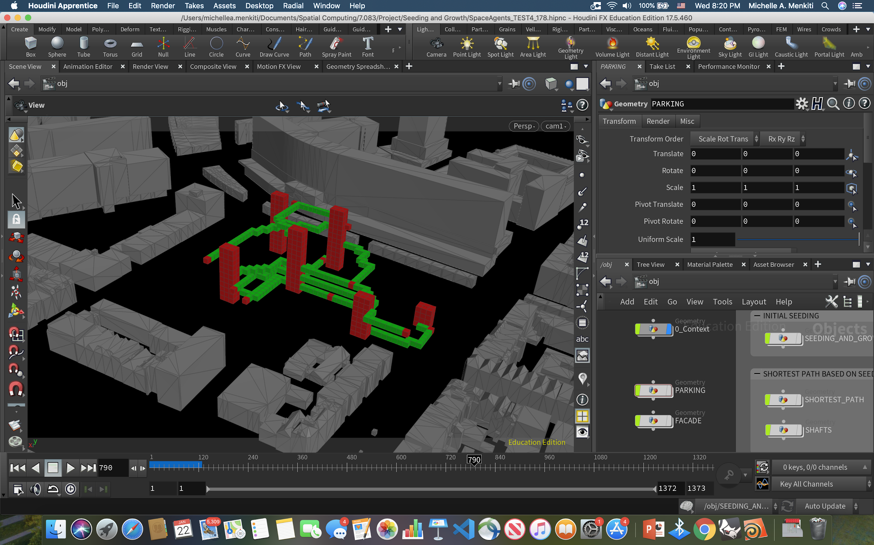

SHORTEST HORIZONTAL PATH TO CLOSEST SHAFTS AND TO END SEED

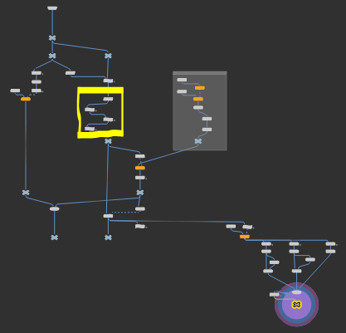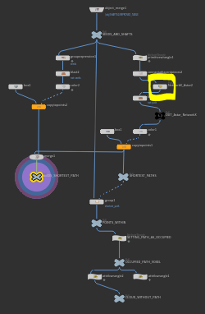

//A: PREPARE NEW ATTRIBUTE TO HOLD THE POINT ID OF THE CLOSEST SHAFT POINT TO ALL START POINT SEEDS

//get number of shafts

int shaft_count = 0;

for (int point=0; point < npoints(0); point++)

{

if (point(0,"shaft_origins",point) > -1)

{

shaft_count = shaft_count+1;

}

}

//iterate through that number

for (int shaft=0; shaft < shaft_count; shaft++)

{

//preparing attribute name

string attribute_name = "Shaft" + itoa(shaft);

for (int point=0; point < npoints(0); point++)

{

//set default value

setpointattrib(0,attribute_name,point,-1,"set");

}

}

//B: FOR ALL START POINT SEEDS, FIND CLOSEST SHAFT AND SET IN NEW ATTRIBUTE

//if its a parent

if (point(0,"parent",@ptnum) > -1)

{

//closest shaft and min distance

int closest_shaft = -1;

float final_distance = 1000000;

//flatten current parent

vector parent = point(0,"P",@ptnum);

parent *= set(1,0,1);

//loop through all points in cloud

for (int point = 0; point < npoints(0); point++)

{

//if you find a shaft

int shaft_count = point(0,"shaft_origins",point);

if (shaft_count > -1)

{

//shaft position

vector shaft = point(0,"P",point);

//record distance

float curr_distance = distance(parent,shaft);

//if curr_distance is less that final_distance, set as new final

if (curr_distance < final_distance)

{

final_distance = curr_distance;

closest_shaft = shaft_count;

}

}

}

//set closest shaft to shaft count

setpointattrib(0,"closest_shaft",@ptnum,closest_shaft,"set");

}

//C: FOR ALL START POINT SEEDS, FIND POINT ID IN THE CLOSEST SHAFT THAT IS ON THE SAME LEVEL AS THE START POINT SEED AND SET IN ATTRIBUTES CREATED IN STEP A

//FOR EACH PARENT

if (point(0,"parent",@ptnum) > -1)

{

//GET ITS Y VALUE

vector pos = point(0,"P",@ptnum);

float y_value = pos.y;

//FOR EACH SHAFT

for (int point=0; point<npoints(0); point++)

{

int shaft_count = point(0,"shaft_origins",point);

if (shaft_count > -1)

{

//preparing attribute name

string attribute_name = "Shaft" + itoa(shaft_count);

//GET POINT ON SAME YVALUE

vector pos_1 = point(0,"P",point);

int IPX = point(0,"IPX",point);

int IPY = point(0,"IPY",point);

int IPZ = point(0,"IPZ",point);

pos_1 += set(0,y_value,0);

int y_val = y_value/3.0;

int point_ID = -2;

//FIND POINT ID OF POINT IN SHAFT

for (int i=0; i<npoints(0); i++)

{

int IPX_1 = point(0,"IPX",i);

int IPY_1 = point(0,"IPY",i);

int IPZ_1 = point(0,"IPZ",i);

if (IPX_1 == IPX)

{

if (IPZ_1 == IPZ)

{

if (IPY_1 == y_val)

{

point_ID = i;

}

}

}

//Setting point

setpointattrib(0,attribute_name,@ptnum,point_ID,"set");

}

}

}

}

//D: CREATE THE SHORTEST PATH FROM THE START POINT SEED TO THE CLOSEST SHAFT, THEN FROM THAT SHAFT TO THE END POINT SEED

//IN A PYTHON NODE

#set geo to the geometry connected to the node (connect adjacent pieces)

node = hou.pwd()

geo = node.geometry()

#import the numpy library

import numpy as np

import os

hippath = os.environ['HIP']

#get connection data from csv file

fname = "Function_Relationship_3.csv"

fpath = os.path.join(hippath, fname)

print(fpath)

# fhandle = open(fpath, "r")

connection_weight = np.genfromtxt(fpath, dtype=int, delimiter=",")

#initiate the graph

import networkx as nx

G = nx.Graph()

#iterate over the points of geo and add them as nodes of the graph

for point in geo.points():

#retrieve the point number

id = point.number()

#add the node to the graph (G)

G.add_node(id)

#iterate over the prims of geo and add them as edges of the graph

for prim in geo.prims():

#retrieve the prim number (necessary for later)

id = prim.number()

#getting the list of the points

pnts = prim.points()

#add the edge to the graph (G) by creating it from points in pnts

G.add_edge(pnts[0].number(),pnts[1].number())

#set seed_ids to the point ids of the points that are not equal to -1 in the attribute "Seed" inside the geo geometry attached to the node

attrib_name = geo.findPointAttrib("parent")

attrib_closest_shaft = geo.findPointAttrib("closest_shaft")

attrib_shaft0 = geo.findPointAttrib("Shaft0")

attrib_shaft1 = geo.findPointAttrib("Shaft1")

attrib_shaft2 = geo.findPointAttrib("Shaft2")

attrib_shaft3 = geo.findPointAttrib("Shaft3")

attrib_shaft4 = geo.findPointAttrib("Shaft4")

attrib_shaft5 = geo.findPointAttrib("Shaft5")

seed_ids = [0 for i in range(13)]

shaft_index = [0 for i in range(13)]

shaft_points = [0 for i in range(13)]

#go through all points and getting the point IDS of parents

for point in geo.points():

myseed = point.intAttribValue(attrib_name)

myclose_shaft = point.intAttribValue(attrib_closest_shaft)

myShaft0 = point.intAttribValue(attrib_shaft0)

myShaft1 = point.intAttribValue(attrib_shaft1)

myShaft2 = point.intAttribValue(attrib_shaft2)

myShaft3 = point.intAttribValue(attrib_shaft3)

myShaft4 = point.intAttribValue(attrib_shaft4)

myShaft5 = point.intAttribValue(attrib_shaft5)

if myseed != -1:

#get the point ID

ptnum = point.number()

##add the point ID at index parent

seed_ids[myseed] = ptnum

shaft_index[myseed] = myclose_shaft

#make a list of shaft ID

parent_points = [myShaft0,myShaft1,myShaft2,myShaft3,myShaft4,myShaft5]

#add list to shaft points

shaft_points[myseed] = parent_points

#group the points that are in the path

path_group = geo.createPointGroup("path")

print("reset")

#looping through the table and finding connections equal to 1

for i, row in enumerate(connection_weight):

for j, col in enumerate(row):

if col == 1:

#setting you start and end nodes

start_i = seed_ids[i]

end_f = seed_ids[j]

#print(start,end)

#get temp end point

m = shaft_index[i]

end_i = shaft_points[i][m]

#if there is a point to go to

if end_i != -2:

#Part 1

#find the shortest path using A-star algorithm

path_nodeid_s = nx.astar_path(G, start_i, end_i)

#retrieve the point object given the point number

path_points_s = [geo.points()[id] for id in path_nodeid_s]

path_group.add(path_points_s)

#get temp start point

start_f = shaft_points[j][m]

#if there is a point to go to

if start_f != -2:

#Part 2

#find the shortest path using A-star algorithm

path_nodeid_f = nx.astar_path(G, start_f, end_f)

#retrieve the point object given the point number

path_points_f = [geo.points()[id] for id in path_nodeid_f]

path_group.add(path_points_f)